Baking Investigation- Ruby

Fruit and chocolate flapjacks
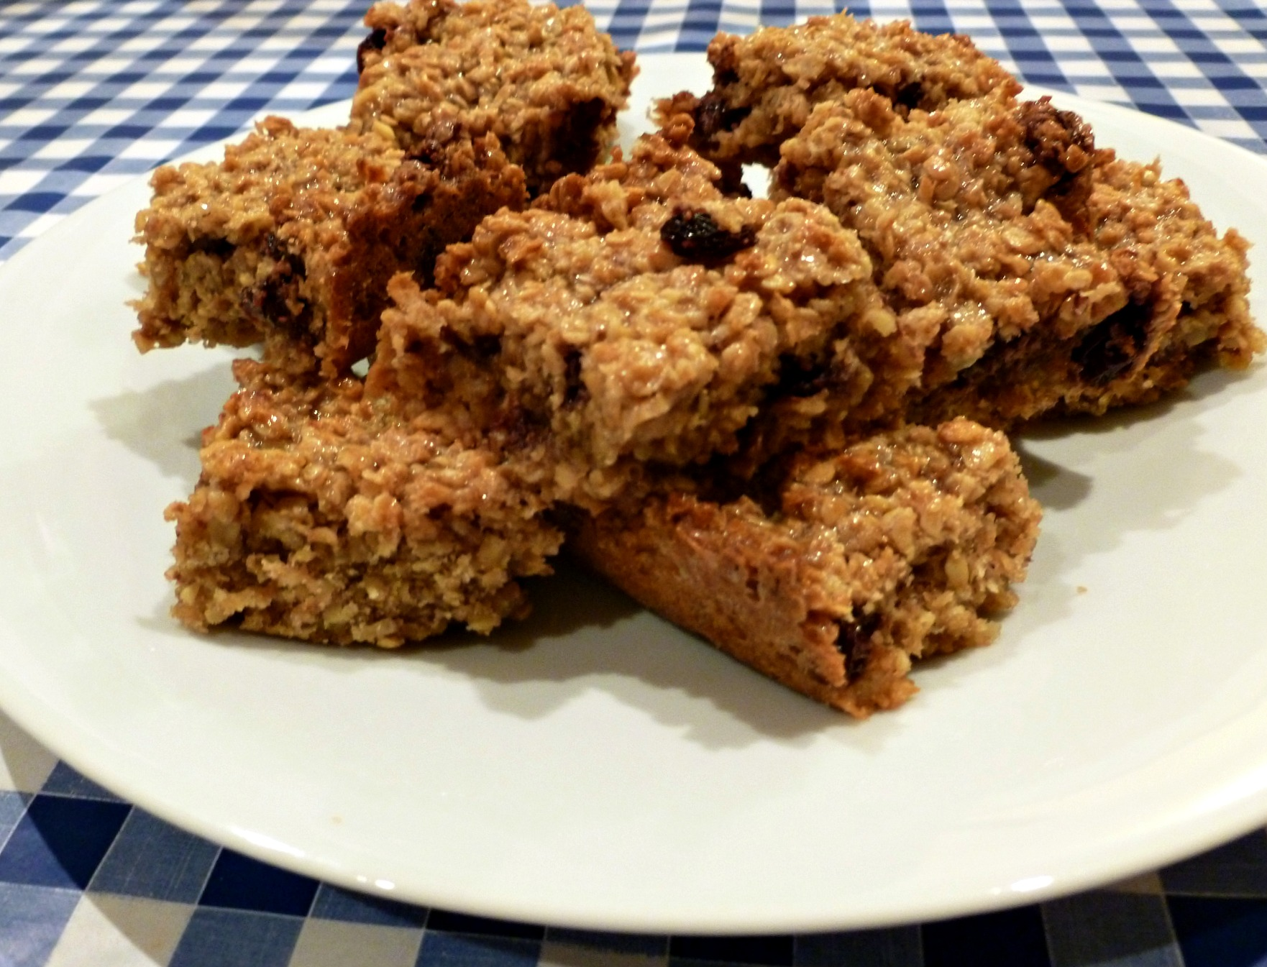

Here are the ingredients I bought:
Oats – the bag weighs 500g
Butter – the packs weigh 240g
Raisins – the bag weighs 120g
Chocolate chips – there were 56 in the bag
Cherries – there were 60 in the bag
Flour – the bag weighs 1kg
Sugar – the bag weighs 1kg

Here are the amounts of each ingredient that I used:
Oats – I used 3/5 of the bag
Butter – I used 1 ½ packs
Raisins – I used 5/6 of the bag
Chocolate chips – I used 5/8 of the bag
Cherries – I used 1/12 of the bag
Flour – I used 1/10 of the bag
Sugar – I used 3/20 of the bag

If you finish writing my recipe, work out how much money I spent on each ingredient too.

Here are the costs for each ingredient (remember, this is the cost of the whole bag or pack – I want to know how much it cost for the amount I used). Write a list of the items and their price in your book.

So, for example oats cost £5.00. But I only used 3/5 of the bag, so what is 3/5 of £5.00? (Hint: remember to work out one fifth first).
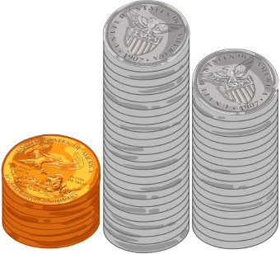
Oats – £5.00
Butter – £1.30
Raisins – 48p
Chocolate chips – 80p
Cherries – £1.20
Flour – £1.40
Sugar – 40p

And if you finish that, work out how much the recipe cost me in total!

