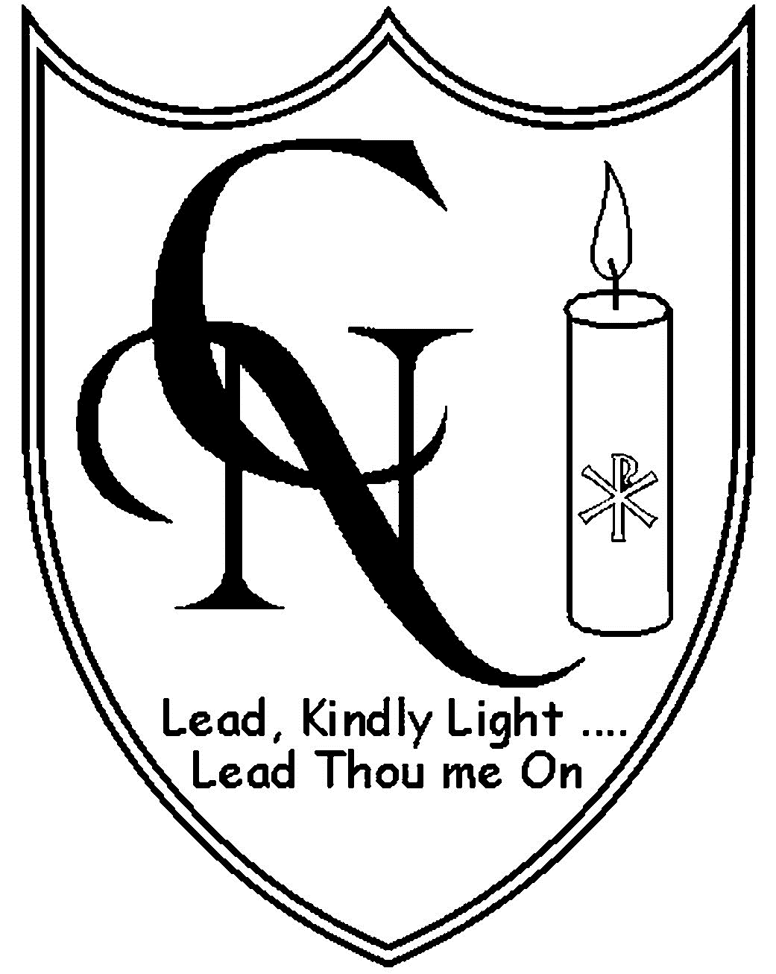 | Cardinal Newman Catholic Primary School  Arch Road, Hersham, Surrey KT12 4QT  Telephone: (01932) 222536  Headteacher: Mrs C Burnham  Email: office@cardinalnewmanschool.co.uk | 

CARDINAL NEWMAN SCHOOL – PARKING PERMIT

Parents at Cardinal Newman School may apply for a free parking permit for Hersham Station car park (in Walton Park). The permit covers morning drop off and afternoon pick up times and the car park is only a short walk from the school. The permit is issued by Elmbridge Borough Council and is sent direct to your home. It needs to be applied for every year and does not renew automatically. We strongly recommend that you take advantage of this free permit to avoid traffic congestion in Arch Road at peak times.

The number of permits that can be issued to Cardinal Newman parents is restricted so please note that:
- Only one permit per family can be issued
- Permits are to be issued only to drivers who will use the car park regularly

Please complete the form below and return to the school office. We will then forward your application to Elmbridge Borough Council.

For further information on the way we use your data, please see the Xavier Catholic Education Trust Privacy Notice at
https://xaviercet.org.uk/wp-content/uploads/2019/02/Xavier-CET-Privacy-Notice-updated-24.5-CM.pdf.
 ------------------------------------------------------------------------------------------
CARDINAL NEWMAN SCHOOL
APPLICATION FOR PARKING PERMIT (HERSHAM STATION CAR PARK)

Name ______________________________________________

Address (incl Post Code)

Car Registration Number ____________________________

