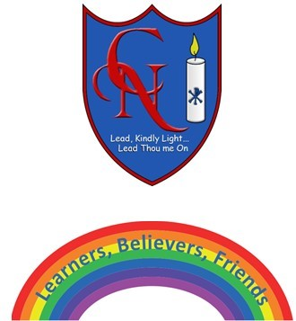
Cardinal Newman Writing Task Year 6

Name:
Learning Objective: To use the monster I have created in a different genre

Success Criteria | Self-assessment | Peer assessment | Teacher assessment
I can write for different purposes and audiences e,g.

★ Write another report about a real animal (lion, great white shark)
★ Write a fact-file for your monster
★ Write a newspaper report about your monster on the loose
★ Write a set of Instructions for ‘How to Trap your Monster’.
★ Write a discussion text - ‘Should Monsters be Allowed to Live on Earth’.

I can include the full range of punctuation in my writing.

I can include carefully chosen vocabulary to engage the reader and maintain interest.

Feedback:

Teacher: Mrs Denmead /Ms.Agostini

