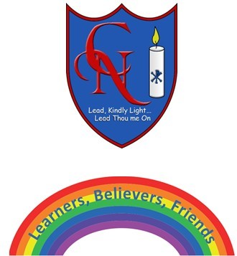
Year 4 Talk for Writing – The King of the Fishes

Name:

Learning Objective: To plan and write a “wishing tale” story based on The King of the Fishes.

Success Criteria | Self-assessment | Peer assessment | Teacher assessment
I can draft, compose and edit work to choose words or phrases to both engage the readers and support the purpose.
I can use commas after fronted adverbials.
I can use precise vocabulary that is lively and imaginative.

Feedback:

Teacher:

