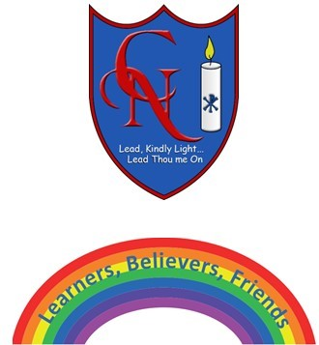
Cardinal Newman Writing Task Year 2

Name:
Learning Objective: To write my own ‘Superhero Adventure,’ using adverbs and expanded noun phrases

Success Criteria | Self-assessment | Peer assessment | Teacher assessment
I can use full-stops,
capital letters, exclamation marks and commas correctly, if needed.
I can use expanded noun phrases to describe my character and the setting of my story.
I can use adverbs to describe how my character moves and speaks.
I can leave an empty line between the beginning, middle and end of my story.
I can edit my story to make corrections and improve it.

Feedback:

Teacher:

