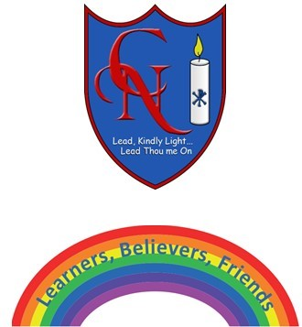
Cardinal Newman Writing Task Year 5 Week 6

Name:
Learning Objective: To develop writing in a range of wizard related texts

Success Criteria | Self-assessment | Peer assessment | Teacher assessment
I can structure my writing and paragraphs for a particular text type
I can use a range of writing tools and vocabulary to make my writing interesting
I can adapt my writing style to match my chosen text type (i.e. persuasive for a advert, descriptive in a story, formal in an invitation etc)

Feedback:

Teacher:

