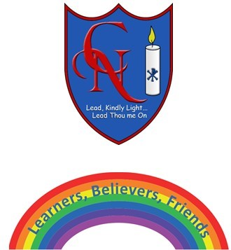
Cardinal Newman Writing Task Year 2

Name:
Learning Objective: To rewrite the story of Pandora’s Box in your own words

Success Criteria | Self-assessment | Peer assessment | Teacher assessment
I can use full stops and capital letters accurately, including exclamation marks.
My story has a clear beginning, middle and end.
The story is in the correct sequence.
I can use a range of words to start my sentences.

Feedback:

Teacher:

