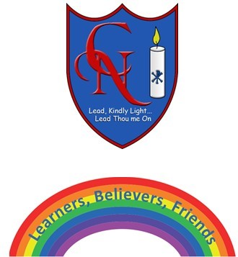
Cardinal Newman Writing Task Year 1

Name:
Learning Objective: To write a letter to Sam and Polly

Success Criteria | Self-assessment | Peer assessment | Teacher assessment
I can use full stops and capital letters accurately.
I can make my letters sit on the line and use my best cursive handwriting.

I can use conjunctions to join my ideas together (and, but, so, because)

Feedback:

Teacher:

