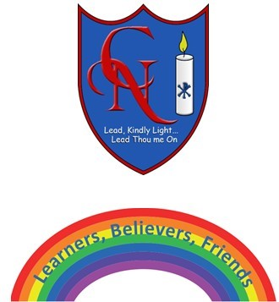
Cardinal Newman Writing Task Year 1

Name:
Learning Objective: To retell the story of Brian Bear’s Picnic!

Success Criteria | Self-assessment | Peer assessment | Teacher assessment
I can sequence the story correctly.
I can make my letters sit on the line and use my best cursive handwriting.

I can use time conjunctions: First, then, next, after, finally.
I can use capital letters to begin and sentence and show they are capital letters by making them bigger than my lowercase letters.
I can end sentences with a full stop.

Feedback:

Teacher:

