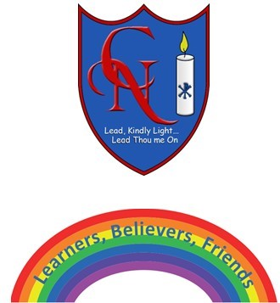
Cardinal Newman Writing Task Year 1

Name:
Learning Objective: To write a thank you letter to Curtis, Bertha and Gertie.

Success Criteria | Self-assessment | Peer assessment | Teacher assessment
I can make my letters sit on the line and use my best cursive handwriting.

I can use a variety of conjunctions (because, and, but, so).
I can use capital letters to begin a sentence and show they are capital letters by making them bigger than my lowercase letters.
I can end sentences with a full stop.

Feedback:

Teacher:

