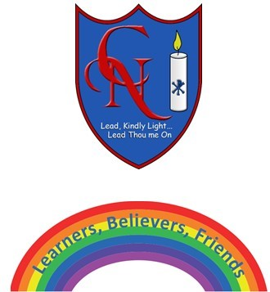
Cardinal Newman Writing Task Year 1

Writing a treasure chest description.
Name:
Learning Objective: To describe items in my treasure chest

Success Criteria | Self-assessment | Peer assessment | Teacher assessment
I can use full stops and capital letters accurately.
I can make my letters sit on the line and use my best cursive handwriting.
I can use interesting adjectives.
I can use the conjunction ‘because’

Feedback:

Teacher:

