Greek Olympic Games
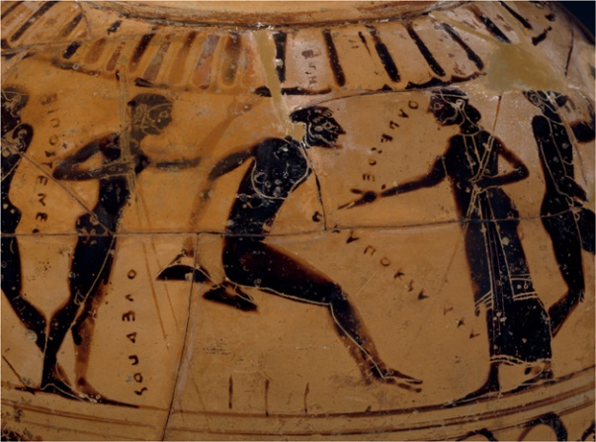
776 BC

Olympic Games
The Olympic Games began over 2,700 years ago in Olympia, in southwest Greece. The Games were part of a religious festival. The Greek Olympics, thought to have begun in 776 BC, inspired the modern Olympic Games (begun in 1896) The Games were held in honour of Zeus, king of the gods, and were staged every four years at Olympia, a valley near a city called Elis. People from all over the Greek world came to watch and take part.

Battle of Marathon
490 BC
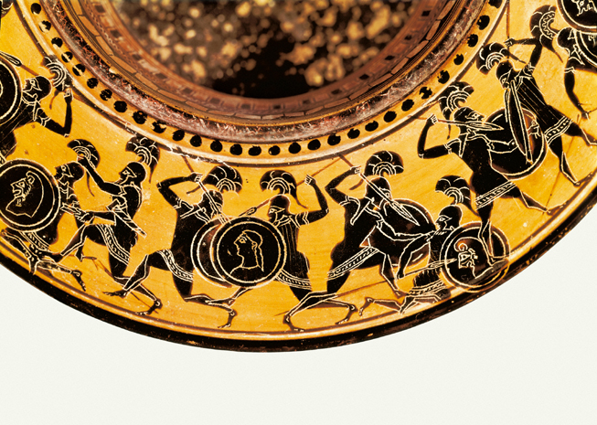

The Battle of Marathon
The Battle of Marathon was a famous Greek victory against the Persians. About 10,000 Greeks, mostly from Athens, fought an army of 20,000 Persians led by King Darius. The Greeks surprised their enemies by charging downhill straight at the Persians.
Marathon is remembered for the heroism of a Greek named Pheidippides. Before the battle, he'd run for 2 days and nights - over 150 miles (240 km) - from Athens to Sparta to fetch help. Then he fought at Marathon. After the battle, he ran 26 miles (42 km) non-stop to Athens, but died as he gasped out the news of victory. The modern Marathon race is over the same distance as his epic run from Marathon to Athens.
The Athenians were led by Miltiades, a soldier who had fought in the Persian army and knew how to beat them. He led the Athenians to victory.
Greek Theatre
440 BC

Greek theatre
Most Greek cities had a theatre. It was in the open air, and was usually a bowl-shaped arena on a hillside. Some theatres were very big, with room for more than 15,000 people in the audience.
All the actors were men or boys. Dancers and singers, called the chorus, performed on a flat area called the orchestra. Over time, solo actors also took part, and a raised stage became part of the theatre. The actors changed costumes in a hut called the "skene". Painting the walls of the hut made the first scenery.
The plays were comedies (funny, often poking fun at rulers) or tragedies (sad and serious, with a lesson about right and wrong).

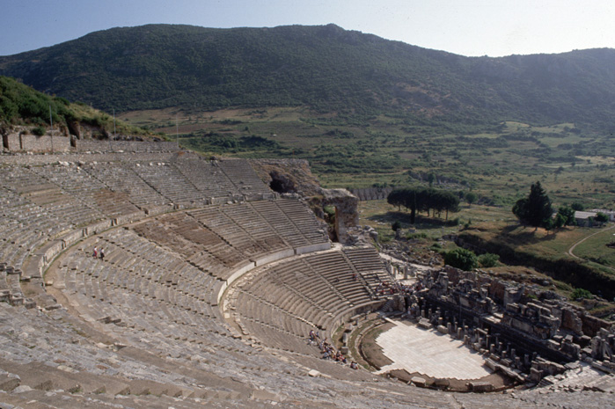
Athens and Sparta war
431 BC – 404 BC
War
In ancient Greece, the great rival of Athens was Sparta. The city-state and its surrounding area were located on the Peloponnesus, southwest of Athens. Sparta.
The Spartan armies, though usually quite small, were well-trained and all but irresistible in combat. Each citizen soldier lived to fight or die. The Spartan mother, when she gave her son his shield, would say: "Bring back this shield yourself or be brought back upon it," referring to the manner in which the dead were carried on their shields from the battlefield. Sparta's powerful side naturally brought rivalry with Athens, the leader of the northern states and for a time of all Greece. This rivalry culminated in the Peloponnesian War (431-404 BC), which resulted in Athens' ruin and Sparta's supremacy
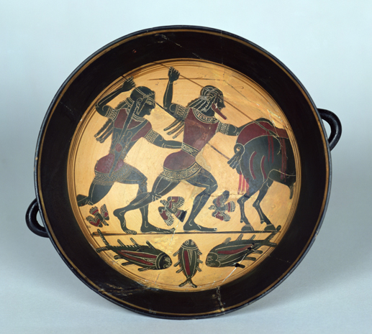

End of Roman Empire
455 AD
The fall of Rome
Rome had quite a run. First a monarchy, then a republic, then an empire – all roads led to Rome for over 1200 years. In the Mediterranean, Rome was in charge. During the Imperial period, Rome had some wonderful emperors. Rome also suffered from a series of bad, corrupt and just plain crazy emperors. There were lots of reasons why Rome fell.
Problems towards the end of the Empire included:
- The empire was too big to manage
- The army was not what it used to be. The generals were found to be dishonest
- Wars between each other broke out
- The amount of slaves increased, putting many Romans out of work
- The rich became lazy and did not want to help to solve the Roman problems
The ancient Romans tried to solve some of their problems by splitting the Roman Empire in half, hoping that would make the empire easier to manage. Each side had an emperor, but the emperor in charge was the emperor of the western half, the half that included the city of Rome.

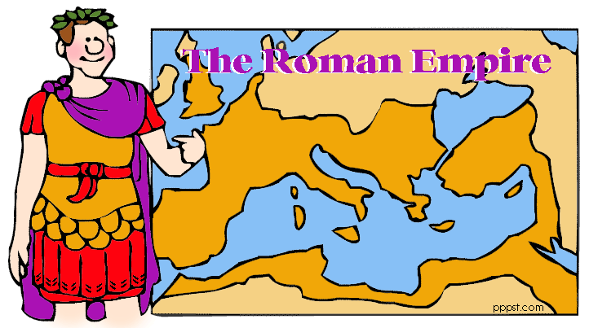

Greek culture
750 BC
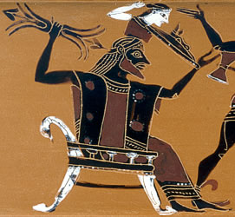

Ancient Greece is called 'the birthplace of Western civilisation'. The Greeks created a way of life that other people admired and copied. The Romans copied Greek art and Greek gods, for example. The Ancient Greeks tried out democracy (an equal way of life),started the Olympic Games and left new ideas in science and art.
The Ancient Greeks lived in Greece and the countries that we now call Bulgaria and Turkey. The Ancient Greece empire spread over Europe as far as France in the East. The Greek Empire was most powerful between 2000 BC and 146 BC. The ancient Greeks developed new ideas for government, science, philosophy, religion, and art. Ancient Greece was split into many different states, each one was ruled in its own way. Each state had its own laws, government and money but they shared the same language and religion. The two most important city states were Athens and Sparta.

Athens
450 BC

Why Athens was great
Athens was the largest city in Greece, and controlled a piece of land called Attica. Between the many mountains were fertile valleys, with many farms. Athens became rich because Attica also had valuable sources of silver, lead and marble. Athens also had the biggest navy in Greece.
Athens was a beautiful and busy city. People came to the city from all over Greece, and from other countries, to study and to trade. The city's most famous building was the temple called the Parthenon. It stood on a rocky hill called the Acropolis. Inside the Parthenon stood a statue of the city's protector-goddess Athena.

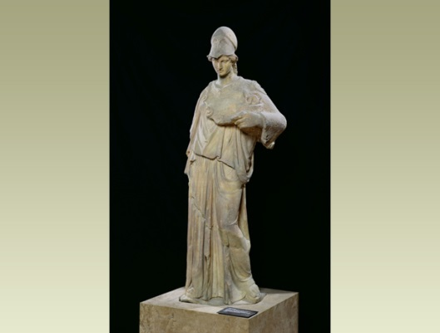

Parthenon
432 BC

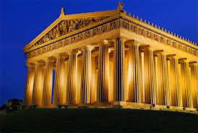
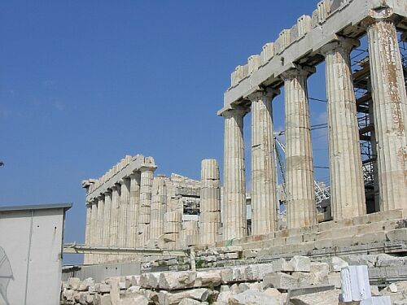
When was it built?
It was built 447-432 BC. The older shrines and temples were destroyed by the Persians when they hit Athens in 480 BC. When the Athenians returned to their city, it was agreed that these would not be built as a reminded of the Persian war they won.

What was in and on the Parthenon building?
A huge statue of Athena made of gold and ivory standing 13 metres high was inside with painted sculptures outside. The west of the building shows Athena and Poseidon’s contest for support of Athens. The east showed Athena’s birth from the head of Zeus. There are also symbols on the southside of the building which shows the battle between Greeks and centaurs (half man- half horse). The others showed Greeks versus Amazons, Trojans and the battle of the gods and the giants.

End of Greek empire
146 BC
What happened?
In 146 BC, Greece was made part of the Roman Empire after they lost a war. The end of the Ancient Greeks came to an end as the Roman Empire expanded. The Greeks fought against the invading Romans but were eventually conquered because they were too strong and powerful. At the time Greece was very fragile for a number of reasons;
- Conflict and competition between cities broke down a sense of community in Greece
- The poor people did not trust the people who ruled the country anymore
- Slavery began to happen and this took work (and money) away from the Greek people

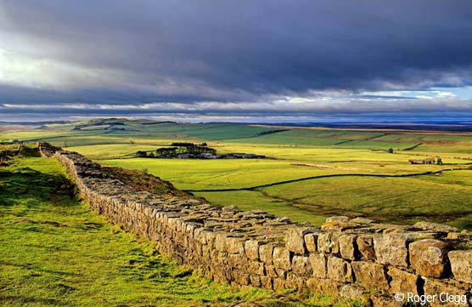

Modern Olympic Games
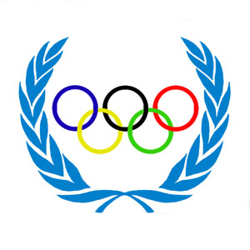
1896 AD

What is it?
The Olympic Games is an international athlete’s competition which is held every four years at a different place. The modern Olympic Games began in the Spring of 1896 by a group called the International Olympics Committee (IOC). The IOC decided that lots of people should be able to take part from all over the world and selected Athens, Greece, as the first place of the Olympic Games. The first modern games, held in April 1896, attracted athletes from the United States, Great Britain and 11 other countries. Over 42 events in 9 sports were schedules for these games.
Ceremonies
A decorative ceremony traditionally opens the Olympic Games. The athletes walk around the stadium, led by the Greek team, in honour of founding the Olympic Games. The host nation marches in last. The Olympic Hymn is then played and the official Olympic flag (five interlocking rings on a white background) is raised. A runner enters the stadium bearing the Olympic torch, originally lit by rays of the sun at Olympa, Greece. The torch is then taken to the site of the games by a relay of runners. The ceremony closes with the release of doves, symbolising the spirit of the games.

