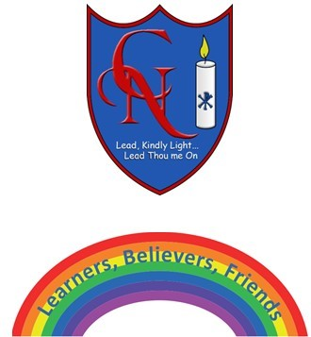
Cardinal Newman Writing Task Reception

Name:

Learning Objective: To write about memories of Reception

We are looking for: | Did you remember? (Please tick these 3 boxes below.)
Key words and sounds written accurately
Using good words for what you remember and felt
Capital letters at the start of writing and sentences.
Feedback
What you did really well

What you can practice next

Teacher:

