Year 4 Writing Task – Descriptive Writing
We know you have all been working hard and trying your best with your home learning. This week we would like you ALL to complete a piece of writing which we will mark and give you some feedback.
We would like you to start your English work this week on Hamilton Week 7 day 4 as the focus for the week will be descriptive writing. Do you remember the story of ‘Adventure at Sandy Cove’ and how we planned a piece of writing in class using our senses? (hear, see, touch, smell and taste)
Monday
Work through the plans for day 4 – chose a seaview and write a description
Tuesday
Work through the plans for day 5 – Stormy weather
Wednesday
Planning your own story
You can use a story mountain to help you plan your writing. Do a section at a time just as we did in class. 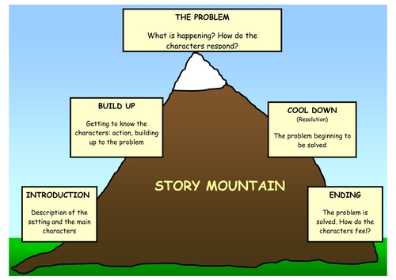
You could even act out your idea to help generate ideas.

Thursday and Friday
Time to start writing up your story.
Really try to be creative and let your imaginations flow. Think about using the full range of punctuation you have been taught and be brave with your vocabulary choices.
- Your writing could be on the page on the Hamilton plan or on your own paper – we are expecting to see at least one page of A4.
- At the top of your work we want to see your name, a date and title (all underlined)
- You will also have a marking sheet – just like the stickers we use in class.
- When you have finished your story, try to self assess in green against the success criteria, and then ask a member of your family to peer assess in pencil.
As you know a good piece of writing takes several days, so don’t worry about days 1,2 and 3 of Hamilton this week.
We are looking for your very best work, so make sure you give it the time it deserves. Finally when you have finished, email it to Y4homelearning@cardinalnalnewmanschool.co.uk by June 1st.
If you want to really impress us, why not add some illustrations.
We can’t wait to read your stories, as teachers we love reading children’s writing and it is something we have really missed. We will then return the marking sheet to you so you know which aspects of the work you have done well and what your next steps are.
Happy writing
Mrs Fleming and Mrs Simpkin

