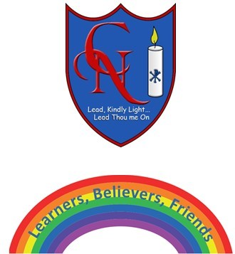
Cardinal Newman Writing Task Year 6

Name:
Learning Objective: To write an organised and detailed description of your monster

Success Criteria | Self-assessment | Peer assessment | Teacher assessment
I can plan and write an organised description with clear paragraphs about appearance, habitat, diet, warning signs etc.
I can make exciting vocabulary choices including interesting noun phrases and adverbial phrases.
I can use the full range of punctuation in my writing
Capital letters, full stops. Commas, exclamation marks, question marks, brackets, apostrophes, colons, semi-colons

Feedback:

Teacher:
Mrs Denmead/Ms. Agostini

