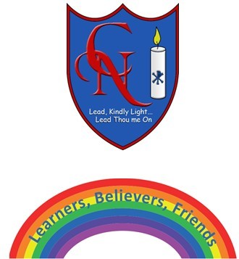
Cardinal Newman Writing Task Year 2

Name:
Learning Objective: To write a poem about their experience of home learning

Success Criteria | Self-assessment | Peer assessment | Teacher assessment
I can use full stops and capital letters and commas correctly.
I can set my work out in the style of a poem.
My poem includes interesting vocabulary.
I can include some rhyming words and/or similes.

Feedback:

Teacher:

