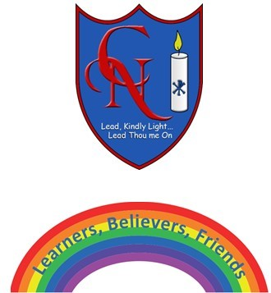
Cardinal Newman Writing Task Reception

Name:

Learning Objective: To write about an animal using key words and sounds.

We are looking for: | Did you remember? (Please fill in and send back to us with your writing.)
Key words written accurately
Using all the sounds you can hear in a word
Thinking of good words to use

Feedback
What you did really well

What you can practise next

Teacher:

