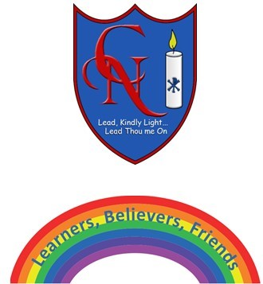
Cardinal Newman Writing Task 3 Year 6

Name:
Learning Objective: To write a portal story exploring what you see and hear through the eyes of the main character

Success Criteria | Self-assessment | Peer assessment | Teacher assessment
I can plan and write a portal story, through the eyes of the main character with a clear structure.
I can include several pattern of three sentences (activity 8), and start some sentences with verbs and adverbs
I can include the full range of punctuation in my writing including some sentences with semi-colons which I practised in Activity 7

Feedback:

Teacher:

