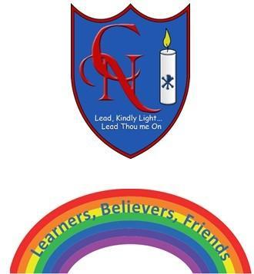
Cardinal Newman Writing Task Year 3

Name:
Learning Objective: To write a log.

Success Criteria | Self-assessment | Peer assessment | Teacher assessment
I can write a log using paragraphs .

I can use, and, but, because, after that and fronted adverbials.
I can use commas after fronted adverbials.

I can use the full range of punctuation in my writing
Capital letters, full stops, commas.

Feedback:

Teacher:

