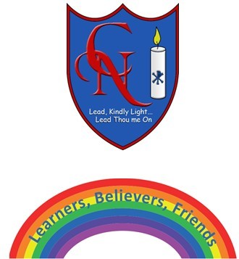
Cardinal Newman Writing Task Reception

Name:

Learning Objective: To write some sentences to describe a dog using key words and full stops

We are looking for: | Did you remember?
Key words written accurately
Using all the sounds you can hear in a word
Thinking of good words to use

Feedback
What you did really well

What you can practice next

Teacher:

