Reception Writing Task
We enjoyed reading the descriptions you wrote last week. Thank you for sending them to us. Now you are getting older, it is important to write sentences as well as key words.
This week we would like you ALL to write about a snail who went to sea on an adventure? Try to use interesting words. Remember to use full stops and, if you can, capital letters. We will be excited to read your adventure stories to see what happened to the snail and to tell you how good you are getting at writing using sounds.

We would like you to write an adventure that happened at sea.
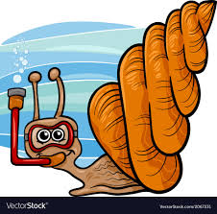
Did the snail go on an adventure?
Where did he go?
What happened to him or her?

